A Mini Project Report on

## Title of your project

Submitted in partial fulfillment of the requirements for the award of the degree of

### Bachelor of Engineering

in

### Branch Name

by

### Name of the Student1(Student ID) Name of the Student2(Student ID) Name of the Student3(Student ID) Name of the Student4(Student ID)

Under the Guidance of

### Name of Guide



#### Department of Branch Name

A.P. Shah Institute of Technology G.B.Road,Kasarvadavli, Thane(W), Mumbai-400615

UNIVERSITY OF MUMBAI

#### Academic Year 2020-2021

This Mini Project Report entitled ***“Project Title”*** Submitted by ***“Name of the Stu- dent1”(Student ID),“Name of the Student2”(Student ID),“Name of the Stu- dent3”(Student ID),“Name of the Student4”(Student ID)***is approved for the partial fulfillment of the requirement for the award of the degree of ***Bachelor of Engineering*** in ***Branch Name*** from ***University of Mumbai*** .

(Name)

Guide

Prof. Sachin H Malave

Head Department of Computer Engineering

Place:A.P.Shah Institute of Technology, Thane Date:

This is to certify that the mini project entitled ***“Title of project”*** submitted by ***“Name of student1” (Student ID),“Name of student2” (Student ID),“Name of stu- dent3” (Student ID),“Name of student4” (Student ID)*** for the partial fulfillment of the requirement for award of a degree ***Bachelor of Engineering*** in ***Branch Name.***,to the University of Mumbai,is a bonafide work carried out during academic year 2020-2021.

(Name)

Guide

Prof. Sachin H Malave Dr. Uttam D.Kolekar Head Department of Computer Engineering Principal

External Examiner(s) 1.

2.

Place:A.P.Shah Institute of Technology, Thane Date:

We declare that this written submission represents our ideas in our own words and where others’ ideas or words have been included, We have adequately cited and referenced the original sources. We also declare that We have adhered to all principles of academic honesty and integrity and have not misrepresented or fabricated or falsified any idea/data/fact/source in our submission. We understand that any violation of the above will be cause for disciplinary action by the Institute and can also evoke penal action from the sources which have thus not been properly cited or from whom proper permission has not been taken when needed.

———————————————

(Signature)

———————————————

(Name of Student1 and Student ID) (Name of Student2 and Student ID) (Name of Student3 and Student ID) (Name of Student4 and Student ID)

Date:

#### Abstract

abstract in 10 to 15 lines.

1. Introduction 1

1.1 Problem Definition . . . . . . . . . . . . . . . . . . . . . . . . . . . . . . 1

1.2 Objectives . . . . . . . . . . . . . . . . . . . . . . . . . . . . . . . . . . . 2

1.3 Scope . . . . . . . . . . . . . . . . . . . . . . . . . . . . . . . . . . . . . 2

1.4 Existing System/Project . . . . . . . . . . . . . . . . . . . . . . . . . . . 3

1. Technology Stack 4
2. Benefits and Applications 5

3.1 Benefits for society . . . . . . . . . . . . . . . . . . . . . . . . . . . . . 5

3.2 Benefits for environment . . . . . . . . . . . . . . . . . . . . . . . . . . 5

3.3 Applications. . . . . . . . . . . . . . . . . . . . . . . . . . . . . . . . . 5

1. Project Design 6

4.1 Proposed System . . . . . . . . . . . . . . . . . . . . . . . . . . . . . . . .6

4.2 Flow of Modules. . . . . . . . . . . . . . . . . . . . . . . . . . . . . . . 7

4.3 Data Flow Diagram. . . . . . . . . . . . . . . . . . . . . . . . . . . . . . 8

**5 Annexure A**

5.1 Gantt Chart. . . . . . . . . . . . . . . . . . . . . . . . . . . . . . . . . . . 9

Appendices 10

Appendix-A . . . . . . . . . . . . . . . . . . . . . . . . . . . . . . . . . . . . . . . 10

1.1 Intrusion Detection System . . . . . . . . . . . . . . . . . . . . . . . . . . . 1

1.1 An Example of a Table . . . . . . . . . . . . . . . . . . . . . . . . . . . . . . 2

5.1 Wormhole Attack Comparison with AODV Protocol . . . . . . . . . . . . . . 6

# List of Abbreviations

IDS: Intrusion Detection System

WSN: Wireless Sensor Network MANET: Mobile Ad-Hoc Network

AODV: Ad-Hoc On-demand Distance Vector Routing DSR: Dynamic Source Routing Protocol

NS2: Network Simulator 2

ACK: Acknowledgement

AGT: Agent

RTR: Router

# Chapter 1 Introduction

The title of Chapter 1 shall be Introduction. It shall justify and highlight the problem posed, define the topic and explain the aim and scope of the work presented in the report. It may also highlight the significant contributions from the investigation.

## Section

You can also create section and subsection

A chapter can be divided into Sections, Sub-sections and Sub-sub Sections so as to present different concepts separately.

### Subsection

Sections and sub-sections can be numbered using decimal points, e.g. 2.2 for the second section in Chapter 2 and 2.3.4 for the fourth Sub-section in third Section of Chapter 2.

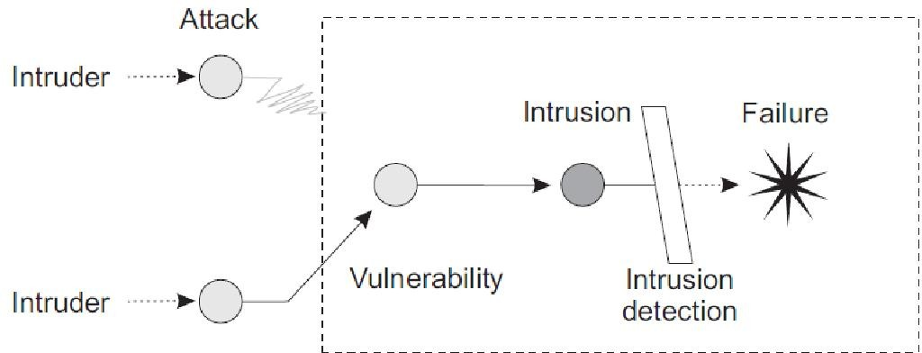

Figure 1.1: Intrusion Detection System

#### Host-based IDS and

1. **Network-based IDS.**
2. **Specification based Intrusion Detection.**
   * 1. **Use of Bullets**

ˆ item 1

ˆ item2

ˆ item3

ˆ item4

### Use of Tables

|  |  |
| --- | --- |
| One | Two |
| Three | Four |

Table 1.1: An Example of a Table

# Technology Stack

# Benefits and Applications

# Project Design

# Annexure A

# 5.1 Gantt Chart

1. Abror Abduvaliyev, Al-Sakib Khan Pathan, Jianying Zhou, Rodrigo Roman and Wai- Choong Wong ,“On the vital Areas of Intrusion Detection Systems in Wireless Sensor networks”,IEEE Communications Surveys & Tutorials, Accepted For Publications, 2013- in press.
2. H.H. Soliman, et al,“A comparative performance evaluation of intrusion detection tech- niques for hierarchical wireless sensor networks”, Egyptian Informatics Journal (2012) 13, 225238.
3. Giannetsos Athanasios, “Intrusion Detection in Wireless Sensor Networks”, Master THE- SIS, Carnegie Mellon University, April 8, 2008.
4. K.Fall and K.Varadhan,“The NS Manual”, [http://www.isi.edu/nsnam/ns/doc/ns](http://www.isi.edu/nsnam/ns/doc/ns%20%20) doc.pdf., 1 Feb 2014.
5. Jae Chung and Mark Claypool,“NS by Example-Tutorial”,<http://nile.wpi.edu/NS/overview.html>, 1 Feb 2014.
6. Network Simulator blog, [http://Mohittahilani.blogspot.com](http://Mohittahilani.blogspot.com/) , 1 Feb 2014.
7. AWK Script for NS2, <http://mohit.ueuo.com/AWK-Scripts.html>, 1 Feb 2014.

Detailed information, lengthy derivations, raw experimental observations etc. are to be presented in the separate appendices, which shall be numbered in Roman Capitals (e.g. Appendix I). Since reference can be drawn to published/unpublished literature in the ap- pendices these should precede the Literature Cited section.

## Appendix-A: NS2 Download and Installation

1. Download ns-allinone-2.35.tar.gz from <http://sourceforge.net/projects/nsnam/>
2. Place ns-allinone-2.35.tar in your desired directory; like /home/vishal.
3. Go to terminal and do as following commands

#### sudo apt-get update

**sudo apt-get install automake autoconf libxmu-dev build-essential**

1. Extract ns-allinone-2.35 and after extracting go to folder ns-allinone-2.35 from Termi- nal as

#### $cd ns-allinone-2.35

$**./install**

1. Path Setting

#### $ gedit .bashrc

This command will open an existing file in editor. Just put the following path which is given bellow. [Remember that our ns-allinone path is /home/vishal. we will change this path according to our ns-allinone folder’s path]

export PATH=$PATH:/home/vishal/ns-allinone-2.35/bin:/home/vishal/ns-allinone-2.35/tcl8.5.10/ unix/home/vishal/ns-allinone-2.35/tk8.5.10/unix

export LD LIBRARY PATH=$LD LIBRARY PATH:/home/vishal/ns-allinone- 2.35/otcl-1.14:/home/ vishal/ns-allinone-2.35/lib

export TCL LIRARY PATH=$TCL LIBRARY PATH:/home/vishal/ns-allinone-2.35/tcl8.5.10/library

After this save and exit.

1. Now type in terminal to check that, is all command we entered in .bashrc is correct or not? And To take the effect immediately

#### $source .bashrc

1. Then perform the validation test using this command.

#### $ ./validate

1. Run ns2 using this command

$**ns**

We will get % prompt in our terminal. Now ns2 has been installed.

**Acknowledgement**

We have great pleasure in presenting the mini project report on **Project Title.** We take this opportunity to express our sincere thanks towards our guide **Guide Name** Department of Computer Engineering, APSIT thane for providing the technical guidelines and suggestions regarding line of work. We would like to express our gratitude towards his constant encouragement, support and guidance through the development of project.

We thank **Prof.Sachin Malave** Head of Department, Computer Engineering, APSIT for his encouragement during progress meeting and providing guidelines to write this report.

We also thank the entire staff of APSIT for their invaluable help rendered during the course of this work. We wish to express our deep gratitude towards all our colleagues of APSIT for their encouragement.

#### Student Name1:

**Student ID1:**

**Student Name2:**

**Student ID2:**

**Student Name3:**

**Student ID3:**

**Student Name4:**

**Student ID4:**

12